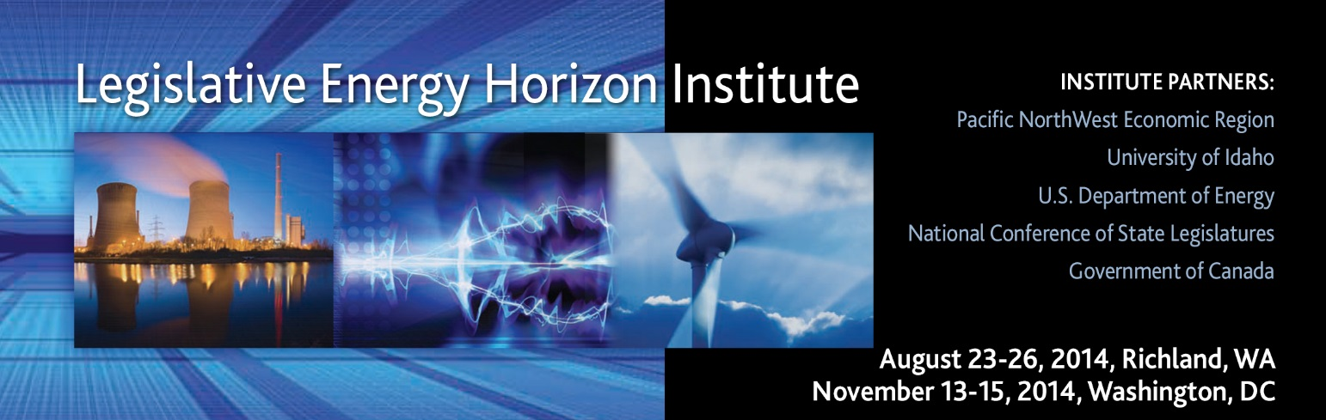

AGENDA – RICHLAND, WA

Friday, August 22, 2014
1:30-5:30pm | Energy Northwest Columbia Generating Station Nuclear Plant Tour  76 North Power Plant Loop / Richland, WA 99354  509.372.5000  (Bus will depart from the hotel to take you to and from the tour)
7:00-8:30pm | Hospitality Welcome  Courtyard by Marriott, Richland Columbia Point  480 Columbia Point Drive / Richland, WA 99352 / 509.942.9400 / 509.942.9401
9:00-10:30pm | Hospitality Suite Open, Room 215
Saturday, August 23, 2014
All Classroom Sessions are in the Environmental Molecular Sciences Laboratory Auditorium
3335 Innovation Blvd, Richland, WA 99354
7:00-8:45am | Breakfast (voucher in your check-in packet)  Courtyard by Marriott, Richland Columbia Point  480 Columbia Point Drive / Richland, WA 99352
9:00am | Bus Leaves for Pacific Northwest National Laboratory (you will need your security badge before we leave the hotel—Badge pick up in the lobby)
9:30am | Welcome (Official Course Start)  Self-knowledge Assessment
9:45am-12:15pm | Electric Power Generation, Transmission, and Distribution
12:15-1:15pm | Lunch discussion on morning session
1:30-5:00pm | Electric Power Generation, Transmission, and Distribution
5:00-6:30pm  (Dinner) | Battery Storage Field Test Unit—Tour and Dinner, EMSL
6:30pm | Bus departs for hotel
8:00-10:00pm | Hospitality Suite Open, Room 215
Sunday, August 24, 2014
All Classroom Sessions are in the Environmental Molecular Sciences Laboratory Auditorium
3335 Innovation Blvd, Richland, WA 99354
7:45am | Bus departs for PNNL
8:00-8:30am | Breakfast at PNNL
8:30-10:00am | US Energy Situation
10:15-11:15am | Natural Gas Production, Transmission, and Delivery
11:20am-12:05pm | Policy Opportunities with EPA’s 111d Rule
12:10-1:20pm  (Lunch) | PNNL’s Energy Infrastructure Operations Center  (Class will split into two groups to tour the center)
1:30-2:30pm | Natural Gas Productions, Transmission, and Delivery
2:45-3:55pm | Petroleum 101
4:00-4:15pm | Biomass for Transportation
4:15-7:30pm  Dinner and Test Drive start at 5:30pm | Alternative Fuels for Transportation  Policies That Work to Support Natural Gas Vehicles  State of Electric Vehicles in North America  Student drive about and Dinner!  3 electric vehicles, 2 propane vehicles, 2 CNG vehicles, 1 LNG truck
7:30pm | Bus departs for hotel
9:00-10:30pm | Hospitality Suite Open, Room 215
Monday, August 25, 2014
All Classroom Sessions are in the Environmental Molecular Sciences Laboratory Auditorium
3335 Innovation Blvd, Richland, WA 99354
7:35am | Bus departs for PNNL
8:00-8:55am | Global Energy Picture  Mark Finley, BP
9:00-10:00am | Financing Energy Projects  Brandon Lohse, Puget Sound Energy
10:05-11:05am | Independent Power Producers, Our Story  Robert Kahn, Northwest Intermountain Power Producers
11:10am-12:10pm | Aligning Utility Regulation with State Energy Policy  Ken Johnson, Puget Sound Energy
12:15-1:15pm  (Lunch) | What is Energy Efficiency?  Andrew Pape-Salmon, RDH Company
1:30-2:30pm | Canada’s Energy Situation  Andrew Leach, Alberta School of Business, University of Alberta
2:40-3:40pm | New Markets for Canadian Natural Gas  Gary Weilinger, Spectra
3:50-5:30pm | Integrated Resource Planning Game  Jason Thackston, Avista
5:35pm | Bus departs for dinner
6:15-8:00pm  (Social and Dinner) | Senior Energy Executive Round Table:  Challenges of Running an Energy Company Today  Mark Reddemann, Energy Northwest  Jason Thackston, Avista  Gary Weilinger, Spectra  Russ Weed, UniEnergy Technologies, LLC  Location  The Reach Museum – Opened July 5, 2014  1943 Columbia Park Trail / Richland WA 99352  “Our primary mission will be one of storyteller…Looking through the lens of the Hanford Reach National Monument and the Columbia River.”
8:30-10:00pm | Hospitality Suite Open, Room 215
Tuesday, August 26, 2014
All Classroom Sessions are in the Environmental Molecular Sciences Laboratory Auditorium
3335 Innovation Blvd, Richland, WA 99354
7:35am | Bus departs for PNNL
8:00-9:00am  (Breakfast) | Rate of Return 101  Phil Jones, Washington State Utility Commissioner
9:10-10:20am | Integrating Renewables  Aaron Bloom, National Renewable Energy Laboratory
10:25-11:50am | Smart Grid  Rob Pratt, PNNL
12:00-1:00pm  (Lunch) | Preview of DC Class Session and Wrap-up
1:00pm | Bus departs for hotel
1:30-3:00pm | Airport or Optional site visit to Nine Canyon Wind Farm

