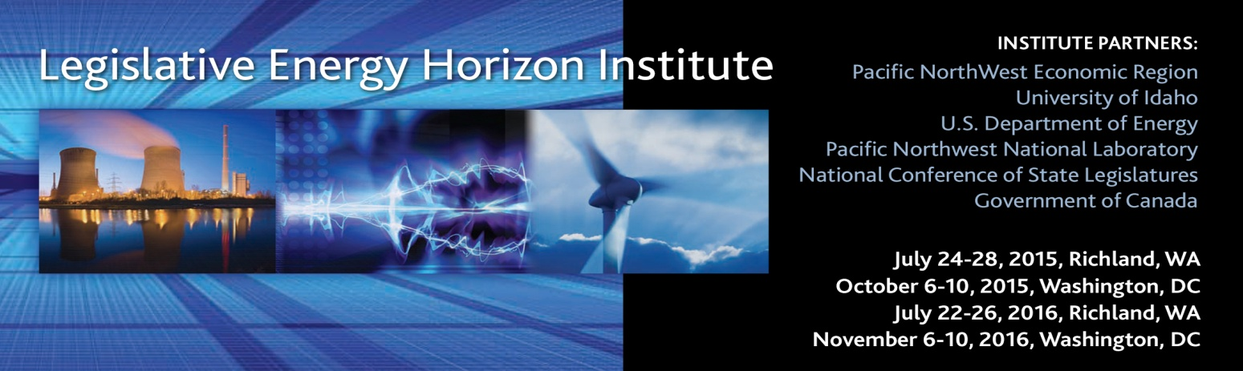
AGENDA – Richland, WA 2015

Friday July 24, 2015
1:30-5:30pm | For those who signed up for optional tour of the 1GW Columbia Nuclear Generating Station Bus leaves hotel at 1:30.
7:00-8:30pm | Hospitality Welcome for Participants arriving August 22, 2014  Courtyard by Marriott, Richland Columbia Point  480 Columbia Point Drive | Richland, WA 99352 | (509) 942-9400
9-10:30pm | Hospitality Suite Open Room 215 at Hotel
Saturday July 25, 2015
All Classroom Sessions Environmental Molecular Sciences Laboratory Auditorium.
3335 Innovation Blvd, Richland, WA 99354
7:00-8:45am | Breakfast At Hotel (voucher in your check-in packet) (you will need your security badge before leaving hotel—Badge pick up in the lobby)  Courtyard by Marriott, Richland 480 Columbia Point Drive, Richland, WA 99352
9:00am | Bus for Pacific Northwest National Lab.
9:30am | Welcome (Official Course start) Self knowledge Assessment Jeff Morris/Yvonne Sertich
9:45-12:15pm | Electric Power Generation, Transmission & Distribution
12:15-1:00pm | Lunch discussion on morning session EMSL 1077/75
1:05-5:00pm | Electric Power Generation, Transmission & Distribution
5:00pm-7:00pm  Dinner | Rate of Return 101
7:00 | Bus Departs for Hotel
8:00-10:00pm | Hospitality Suite Open Room 215 at Hotel
Sunday July 26, 2015
All Classroom Sessions Environmental Molecular Sciences Laboratory Auditorium.
3335 Innovation Blvd, Richland, WA 99354
7:45am | Bus leaves for PNNL
8:00-8:30am | Breakfast at PNNL EMSL 1077/75
8:30-10:30am | Natural Gas Production, Transmission & Delivery
10:35-11:25 | Integrating Renewables
11:30-12:20pm
12:20-1:20 p.m. lunch | PNNL’s Energy Infrastructure Operations Center EMSL 1077/75  Short Presentation by Dr. Jud Virden Associate Laboratory Director for Energy & Environment, PNNL (Class split into two groups to tour center)
1:30 -3:55pm | Petroleum 101
4:00-4:15pm | Biomass
4:15-7:30 pm  Dinner/Test Drive start @ 5:30pm  Bus leaves 7:30 | Alternative Fuels for Transportation  Policies that work to support natural gas vehicles  State of Electric Vehicles in North America  Student Drive about and Dinner!  Bi-Fuel Propane Yukon XL, Bi-Fuel Propane Police Car,  Possible SD 114 CNG Roll-off truck, 2012- Bi-Fuel Propane Chevy Avalanche, 2013 Bi-Fuel CNG Chevy Silverado 4x4, Honda Civic dedicated CNG 3 electric Vehicles
9:00-10:30pm | Hospitality Suite Open Room 215 at Hotel

Monday, July 27, 2015
All Classroom Sessions Environmental Molecular Sciences Laboratory Auditorium.
3335 Innovation Blvd, Richland, WA 99354
7:35am | Bus Leaves for PNNL
8:00-8:30am | Breakfast EMSL 1077/75
8:30-9:25am | Financing Energy Projects
9:35-10:30am | Independent Power Producers, Our Story  Invenergy invited
10:40-11:35 pm | Canadian Natural Gas
11:35-11:55 | Class Morning Session Discussion
12:00-12:55 pm | Lunch EMSL 1077/75
1:00-2:00 | Canada’s Energy Situation
2:10-3:05 | Aligning Utility Regulation with State Energy Policy
3:15-5:15 pm | Integrated Resource Planning Game EMSL 1077/75
5:30pm | Bus departs for Dinner
6:15-8:00pm  Social and Dinner | Senior Energy Executive Round Table  Challenges of Running an Energy Company Today  Location  The Reach Museum --Opened July 5, 2014  "Our primary mission will be one of storyteller... Looking through the lens of the Hanford Reach National Monument and the Columbia River."
8:30-10:00pm | Hospitality Suite Open Room 215 at Hotel

Tuesday, July 28 2015
All Classroom Sessions Environmental Molecular Sciences Laboratory Auditorium.
3335 Innovation Blvd, Richland, WA 99354
7:35am | Bus Departs Hotel for PNNL
8:00-8:30 | Breakfast EMSL 1077/75
8:30-9:20 | Tools for Legislators in LEHI
9:25-10:20am | Smart Grid
10:25-11:50am | Utility 2.0 What will the Utility of the Future look like Part 1.
12:00-1:00pm | Lunch Preview of DC Class Session Wrap up & Lunch EMSL 1077/75
1PM | Bus back to Hotel
1:30-3:00pm | Airport or Optional site visit to Nine Canyon Wind Farm

