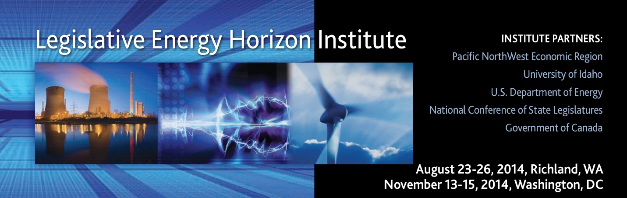

AGENDA – WASHINGTON, DC

Wednesday, November 12, 2014
7:00pm | Informal Dinner Gathering  The Dubliner (202.737.3773)  Number 4 “F” ST / Washington, DC 20001  (Meal and non-alcohol drinks covered)
Thursday, November 13, 2014
7:30am | Breakfast  American Gas Association (AGA)  400 N Capitol ST NW / Washington, DC
8:00-8:30am | Welcome and Assessments
8:30-9:20am | Public Policy Impacts on Business Decisions
9:25-10:20am | Overview of North America’s Aging Infrastructure and Pipeline Safety Best Practices
10:30-11:30am | Role of the Federal Energy Regulatory Commission
11:30am-12:20pm | The Future of Coal
12:30-1:00pm | Lunch Session Class Debrief
1:05-2:05pm | Nuclear Energy: Today and Tomorrow
2:15-3:30pm | What Will State/Province Based Regulation Look Like in 2030?
3:40-4:35pm | Energy Storage Today
4:45-5:00pm | Class Debrief
5:30-7:00pm | Graduation Reception (Walk or Cab)  Embassy of Canada / 501 Pennsylvania AVE NW / Washington, DC
7:15-9:00pm | Dinner (Walk or Cab)  Oyamel Cocina Mexicana (202.628.1005)  401 7th ST NW (corner of 7th and D) / Washington DC 20004
Friday, November 14, 2014
7:30am | Breakfast  American Gas Association (AGA)  400 N Capitol ST NW / Washington, DC
8:00-9:50am | EPA’s 111b and 111d – What Do We Know Today?  Known Unknowns on 111b and 111d
10:00-10:55am | Overview of Industry Practices in Fracturing
11:00-11:55am | State/Provincial and Legal Perspective on Fracturing Regulation
12:00-12:55pm | Lunch Session—Best Practices for Renewable Energy Development
1:05-1:50pm | Rail Safety and Crude
2:00-2:50pm | Crude by Rail, A North American Market
3:00-4:00pm | Class Discussion
4:05-5:00pm | Developing Outcome Based/Technology Neutral Energy Policy
5:00-5:15pm | Class Debrief
6:00-7:45pm | Sponsor Dinner (Casual)  Hill Country Barbeque Market (202.556.2050)  410 7th ST NW / Washington DC 20001
Saturday, November 15, 2014
8:00am | Breakfast  American Gas Association (AGA)  400 N Capitol ST NW, Washington, DC
8:30-9:20am | Wheel of 111b and 111d Classroom Discussion
9:30-10:20am | Future of the Grid
10:30am-12:00pm | LEHI Class of 2014 Crystal Ball – Classroom Discussion
12:00-1:00pm | Lunch Session – Evaluations, Small Group Debrief, and  Sponsor Comment

