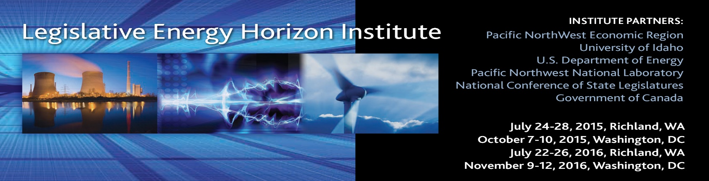
AGENDA – WASHINGTON, DC
Wednesday, October 7, 2015
7:00pm | Informal Dinner Gathering  The Dubliner (202.737.3773)  Number 4 “F” ST, Washington, DC 20001  (Meal and non-alcohol drinks covered)
Thursday, October 8, 2015
7:30am | Breakfast  American Gas Association (AGA)  400 N Capitol ST NW, Washington, DC 20001
8:00-8:30am | Welcome and Assessments
8:30-9:20am | Role of the Federal Energy Regulatory Commission
9:25-10:20am | The Future of Coal
10:30-11:30am | Nuclear Energy: Today and Tomorrow
11:30-12:25pm | Best Policy Practices for Renewable Energy & Enabling Technologies
12:30-1:00pm | Lunch Session Class Debrief
1:05-2:05pm | The Federal Energy Policy Landscape to 2016 and beyond
2:15-3:45pm | What Will State/Province Based Regulation Look Like in 2030?
3:40-4:35pm | Litigation on FERC Order 745 & 1000 --Implications for States
4:45-5:00pm | Class Debrief
5:30-7:00pm | Graduation Reception (Walk or Cab)
7:15-9pm | Dinner Oyamel Cocina Mexicana (Walk or Cab)  401 7th Street NW Washington, DC 20004 (Corner of 7th & D Streets) t. 202.628.1005
Friday, October 9, 2015
7:30am | Breakfast American Gas Association (AGA) 400 N Capitol ST NW 2001
8:00-8:30am  8:30-10:00 | EPA's 111b and 111d—The Final Rule  The Road Ahead on 111b and 111d
10:05-10:55am | Overview of Industry Practices in Fracturing
11:00-11:50pm | Regulatory State/Provincial Perspective on Fracturing Regulation
11:55-12:25pm | Lunch Session Debrief
12:30-1:45pm | Global Energy Picture
1:50-2:40pm | Future of the Grid
2:45-4:00pm | Utility 2.0
4:05-5:00pm | Natural Gas’s Aging Infrastructure, Pipeline Safety & Expansion Best Practices
5:00-5:15pm | Class Debrief
6:00-7:45pm | Sponsor Appreciation Dinner (Casual- Walk or Uber/Cab)  BP DC Office, 1101 New York Avenue, Washington DC
Saturday, October 10. 2015
8:00am | Breakfast  American Gas Association (AGA)  400 N Capitol ST NW, Washington, DC 2001
8:30-11:30 | NARUC/Duke Procurement Risk Simulation
11:30am-12:30pm | LEHI Class of 2015 Crystal Ball/Time Capsule -- Classroom Discussion  Lunch Session Evaluations, Small Group Debrief, and Sponsor Comment

